*Tittle tattle of a Peripatetic*

Kutna Hora, Czech Republic

On your next visit to Prague take a drive or bus to Kutna Hora where you can visit a Bone-chilling churches.

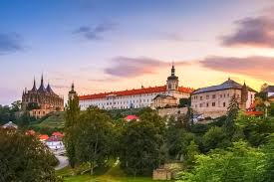

While Prague remains the ‘must visit’ cities in Europe in the last decade, but the historic and impressive city of Kutna Hora stands out as a rare townships featuring the bone chilling Sedlec Ossuary. This makes it ideal for a great day trip from Prague although spending a night there would be great..

As a peripatetic, I have visited this place at least 8 times in over 20 visits to Prague. The cobbled streets, grand architecture, the impressive cathedral and pay a visit to the unique ‘Bone Church’ which can give a chill down your spine. The gothic church built by Schwarzenburg family, is adorned with bones. 4 massive bells, garlands with skull, a coat of arms of the Schwarzenburg family designed by bones. The church built in the center of a cemetery with over 50000 bodies, whose bones are used for this church.

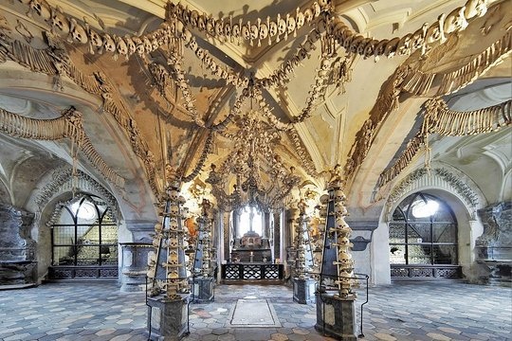

This in many ways was to respect the cemetery that was disturbed during a construction. The city is surrounded by lush woodland surrounding and plenty of Pilsner on tap. A perfect slice of Bohemian experience without the crowds of Prague.

A two-day visit with an overnight stay will give time to see the city, enjoy the nature and unwind yourself.

Kutna Hora is a place to visit, as the bone church has become an Instagram hit and the commune is contemplating a ban on photography soon.

Kutna Hora is connected by road and Trains from Prague and takes about an hour and 30 minutes from Prague.

Kutna Hora video: <https://www.youtube.com/watch?v=jtqvt8zvvV8>

Authur: Anil Edwin

**Ed-wings Global.**

Instagram: #edwingsds, #aniledwin

Twitter:@Edwingsds, @aniledwin

Email: [travel@ed-wings.com](mailto:travel@ed-wings.com), [edwingsglobal1@gmail.com](mailto:edwingsglobal1@gmail.com)